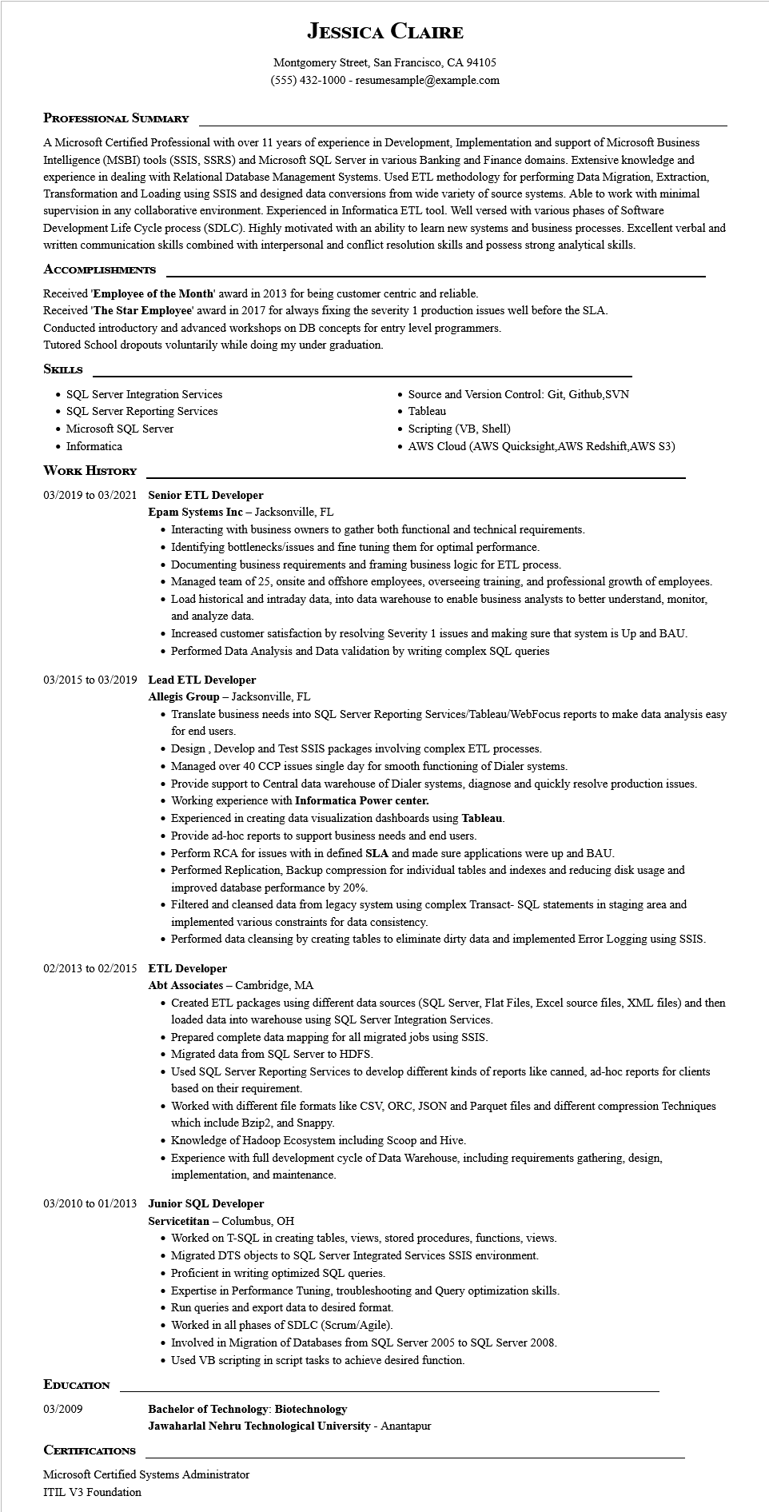
JESSICA CLAIRE
Montgomery Street, San Francisco, CA 94105
(555) 432-1000 - resumesample@example.com
PROFESSIONAL SUMMARY
A Microsoft Certified Professional with over 11 years of experience in Development, Implementation and support of Microsoft Business Intelligence (MSBI) tools (SSIS, SSRS) and Microsoft SQL Server in various Banking and Finance domains. Extensive knowledge and experience in dealing with Relational Database Management Systems. Used ETL methodology for performing Data Migration, Extraction, Transformation and Loading using SSIS and designed data conversions from wide variety of source systems. Able to work with minimal supervision in any collaborative environment. Experienced in Informatica ETL tool. Well versed with various phases of Software Development Life Cycle process (SDLC). Highly motivated with an ability to learn new systems and business processes. Excellent verbal and written communication skills combined with interpersonal and conflict resolution skills and possess strong analytical skills.
ACCOMPLISHMENTS
Received 'Employee of the Month' award in 2013 for being customer centric and reliable.
Received 'The Star Employee' award in 2017 for always fixing the severity 1 production issues well before the SLA.
Conducted introductory and advanced workshops on DB concepts for entry level programmers.
Tutored School dropouts voluntarily while doing my under graduation.
SKILLS
• SQL Server Integration Services
• SQL Server Reporting Services
Microsoft SQL Server
• Informatica
• Source and Version Control: Git, Github, SVN • Tableau
• Scripting (VB, Shell)
• AWS Cloud (AWS Quicksight,AWS Redshift, AWS S3)
WORK HISTORY
03/2019 to 03/2021 Senior ETL Developer
Epam Systems Inc - Jacksonville, FL
• Interacting with business owners to gather both functional and technical requirements.
• Identifying bottlenecks/issues and fine tuning them for optimal performance.
• Documenting business requirements and framing business logic for ETL process.
• Managed team of 25, onsite and offshore employees, overseeing training, and professional growth of employees.
• Load historical and intraday data, into data warehouse to enable business analysts to better understand, monitor, and analyze data.
• Increased customer satisfaction by resolving Severity 1 issues and making sure that system is Up and BAU.
• Performed Data Analysis and Data validation by writing complex SQL queries
03/2015 to 03/2019 Lead ETL Developer
Allegis Group - Jacksonville, FL
• Translate business needs into SQL Server Reporting Services/Tableau/WebFocus reports to make data analysis easy for end users.
• Design, Develop and Test SSIS packages involving complex ETL processes.
• Managed over 40 CCP issues single day for smooth functioning of Dialer systems.
• Provide support to Central data warehouse of Dialer systems, diagnose and quickly resolve production issues.
• Working experience with Informatica Power center.
• Experienced in creating data visualization dashboards using Tableau.
• Provide ad-hoc reports to support business needs and end users.
• Perform RCA for issues with in defined SLA and made sure applications were up and BAU.
• Performed Replication, Backup compression for individual tables and indexes and reducing disk usage and improved database performance by 20%.
• Filtered and cleansed data from legacy system using complex Transact-SQL statements in staging area and implemented various constraints for data consistency.
• Performed data cleansing by creating tables to eliminate dirty data and implemented Error Logging using SSIS.
02/2013 to 02/2015 ETL Developer
Abt Associates - Cambridge, MA
• Created ETL packages using different data sources (SQL Server, Flat Files, Excel source files, XML files) and then loaded data into warehouse using SQL Server Integration Services.
• Prepared complete data mapping for all migrated jobs using SSIS.
• Migrated data from SQL Server to HDFS.
• Used SQL Server Reporting Services to develop different kinds of reports like canned, ad-hoc reports for clients based on their requirement.
• Worked with different file formats like CSV, ORC, JSON and Parquet files and different compression Techniques which include Bzip2, and Snappy.
• Knowledge of Hadoop Ecosystem including Scoop and Hive.
• Experience with full development cycle of Data Warehouse, including requirements gathering, design, implementation, and maintenance.
03/2010 to 01/2013 Junior SQL Developer
EDUCATION
03/2009
CERTIFICATIONS
Servicetitan - Columbus, OH
• Worked on T-SQL in creating tables, views, stored procedures, functions, views.
• Migrated DTS objects to SQL Server Integrated Services SSIS environment.
• Proficient in writing optimized SQL queries.
• Expertise in Performance Tuning, troubleshooting and Query optimization skills.
• Run queries and export data to desired format.
• Worked in all phases of SDLC (Scrum/Agile).
• Involved in Migration of Databases from SQL Server 2005 to SQL Server 2008.
• Used VB scripting in script tasks to achieve desired function.
Bachelor of Technology: Biotechnology
Jawaharlal Nehru Technological University - Anantapur
Microsoft Certified Systems Administrator
ITIL V3 Foundation.

